

**Tribhuvan University**

**Faculty of Humanities and Social Sciences**

**Institute Billing System**

**A PROJECT PROPOSAL**

**Submitted to**

**Department of Computer Application**

**Mechi Multiple Campus**

***In partial fulfillment of the requirements for the Bachelor in Computer Application***

**Submitted by**

Santosh Bhandari - 58

Tikaram Parajuli - 69

July 2023

Under the Supervision of

**Raju Poudel**

**Table of Contents**

1. Introduction 1

2. Problem Statement 1

3. Objectives 1

4. Methodology 2

a. Requirement Identification 2

I. Study of Existing System 2

II. Requirement Collection 3

b. Feasibility Study 4

I. Technical 4

II. Operational 5

III. Economic 5

c. High Level Design of System 6

**5.** **Gantt Chart** 7

6. Expected Outcome 7

7. References 8

# Introduction

The Institute Billing System is a web app designed to automate the billing processes within educational institutes. It introduces an efficient and accurate system by addressing the challenges associated with manual billing methods, which causes errors, delays, and administrative burden. By implementing the Institute Billing System, institutes can enhance their financial management, improve transparency, and provide a user-friendly interface for administrators and user to access billing information.

In today's digital age, educational institutes face the need for robust billing systems that can handle fee structures, generate invoices, and track payments seamlessly. The Institute Billing System aims to meet these requirements by offering features like student information management, Invoice generation, payment tracking, and reporting capabilities. With its automation capabilities, the system eliminates the need for manual calculations and data entry, reducing the chances of errors and saving valuable time for administrative staff.

# Problem Statement

The Manual Billing process leads to many human errors like wrong entry, inaccuracies in fee calculations and invoices. By using the manual billing process, it is hard to track the payment details and keep the correct financial statements as well as time consuming. This will automatically increase the burden to the administration worker. [1]

In traditional billing process, the invoices are generated manually. Every time when the invoices is generated, the students have to mentioned the information about them and the course they have currently taken. Whenever the student want to update their billing information, It is going to be complex in manual billing process.

The Problem of the statement are as follows:

* Invoices are Generate Manually.
* Complex and Time Consuming to Track the Payment Information.

# Objectives

The Objectives are as follows:

* To Develop Web Application for Generating Computerized Invoices.
* To keep record of Payment, Invoices, Due Amount and Student Information.

# Methodology

Here we are going to use the waterfall methodology while building this project. Since this model has specific features and technical clearance. We are implementing this method to make our project success.

By adhering to the waterfall methodology for the development of the project, we aim to deliver a well-planned, documented, and thoroughly tested software solution that meets the specified requirements and provides an efficient and reliable result. [2]

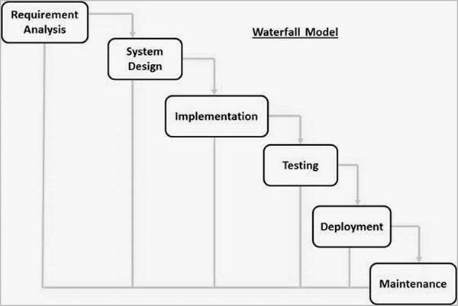

Fig: Waterfall Model

## Requirement Identification

Requirement identification is a crucial step in developing the Institute Billing System, as it lays the foundation for the design and development of the software solution. The process involves studying the existing system, if any, and collecting the necessary requirements to address the institute's billing needs effectively.

### Study of Existing System

The first step in requirement identification for the proposed system is to conduct a thorough study of the existing system. Here, I have considered two existing System i.e. Smart Billing System and MIS.

**Smart Billing System:**

Smart Billing System is an existing billing system which is already developed. It is designed to handle the billing process, including fee calculation, invoice generation, and payment tracking. It offers a user-friendly interface and basic reporting features, providing administrators with essential financial information. Additionally, the system relies on manual calculations and paperwork, which increases the likelihood of errors and requires significant effort from the administrative staff.

Pros:

* The Existing System has a User-friendly Interface.
* It is Integrated with Student Database.
* It has basic reporting features.

Cons:

* The System faces challenges in handling large volume of billing data.
* Calculation of Bill is done manually.

**MIS:**

MIS is also another existing billing system that aims to address the limitations of previous system. It uses modern technologies and a user-friendly interface to streamline the billing process and enhance financial management. It is not designed separately. It integrated with other system.

Pros:

* It uses modern designing concept and technologies.
* It can handle more volume of billed data.

Cons:

* The operational cost is expensive as it is not designed separately.
* Required to upgrade hardware to use modern technologies.

### II. Requirement Collection

After studying the existing system, the next step is to collect the requirements for the System. This involves gathering information about the desired features, functionalities, and objectives of the new system. Requirement collection can be done through various techniques, including interviews, surveys, and meetings. [3]

During the requirement collection phase, the following aspects is considered:

* Billing process automation: Determine the desired level of automation, such as invoice generation, and payment tracking.
* User roles and permissions: Determine the roles and access levels for different users.
* Reporting and Analytics: Understand the reporting requirements, including financial reports, revenue analysis, outstanding payments, and summaries.

During the requirement collection phase, it is important to involve all relevant people to ensure that their needs and expectations are captured accurately. The requirements will serve as the foundation for the design and development of the final System, ensuring that it meets the specific needs and improves upon the limitations of the existing system.

## b. Feasibility Study

Before proceeding with the development of System, a feasibility study is conducted to assess the viability and potential success of the project. This study evaluates various aspects, including technical feasibility, economic feasibility, and operational feasibility, to determine if the project is worth pursuing. [4]

### I. Technical

Technical feasibility assesses whether the development and implementation of the proposed system are achievable using the available technology and resources. It involves evaluating the compatibility of the software solution with the existing infrastructure, hardware, and software systems.

|  |  |
| --- | --- |
| **Parameters** | **Remarks** |
| Hardware Resources | Available |
| Technical Expertise | Yes |
| Programming Language | Free |
| Software Tools | Open Source / Free |

### II. Operational

Operational feasibility assesses whether the proposed System can be smoothly integrated into the existing operations and processes. It focuses on evaluating the system's compatibility with workflow and the acceptance of the system by users.

|  |  |
| --- | --- |
| **Parameters** | **Remarks** |
| User Acceptance | Yes |
| Ease of Use | Yes |
| Training Requirement | Yes |
| Operational Cost | Affordable |

### III. Economic

Economic feasibility assesses the financial viability and benefits of developing and implementing the proposed System. It involves analyzing the costs associated with the project and comparing them with the potential benefits and returns on investment.

|  |  |
| --- | --- |
| **Parameters** | **Remarks** |
| Development Tools | Open Source / Free |
| Servers | Free |
| IDE | Open Source / Free |
| Programming Language | Free |

Based on the findings of the feasibility study, it can be concluded that the proposed System can be developed with a high level of confidence. The technical feasibility assessment indicates that the necessary technical resources and infrastructure are available. The operational feasibility assessment suggests that the proposed system can be seamlessly integrated into the existing operations and can be easily operated. Furthermore, the economic feasibility study demonstrates that the proposed system can be developed cost effectively. Considering these positive outcomes, it is evident that the proposed System has the potential to address the billing needs effectively and improve efficiency, accuracy, and financial management.

## c. High Level Design of System

For better understanding about the system components and functionalities, The System flow chart is presented below:

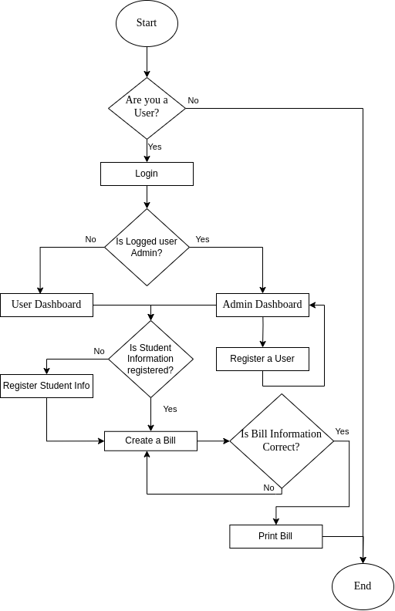

Fig: System Flowchart

1. **Gantt Chart**

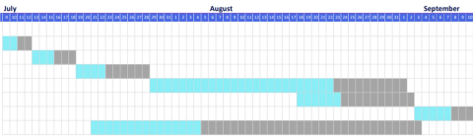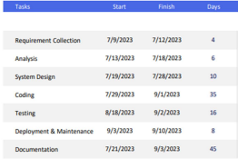The Gantt chart showing work schedule is given below:

Fig: Gantt Chart

# Expected Outcome

The proposed Institute Billing System will bring forth several expected outcomes. Firstly, it will significantly improve the efficiency of the billing process by automating various tasks, eliminating manual calculations, and reducing paperwork. This system will save time and effort for administrative staff, allowing them to focus on other important responsibilities.

Additionally, the system will ensure accurate and timely billing by generating invoices properly, calculating fees with precision, and maintaining the records. This will minimize errors and delays, resulting in a smoother billing experience for students, parents, and staff alike. Furthermore, the system will contribute to enhanced financial management by providing comprehensive reporting and analysis capabilities. Overall, the proposed System will promote transparency, efficiency, and accuracy, transforming the billing process for the better.

# References

|  |  |
| --- | --- |
| [1] | A. K. I. K. V. V. Baswaraju Swathi, "Implementation of Improved Billing System," 2020. |
| [2] | "SDLC - Waterfall Model," [Online]. Available: https://www.tutorialspoint.com/sdlc/sdlc_waterfall_model.htm. |
| [3] | T. Asana, "6-step guide to Requirements Gathering," 13 11 2022. [Online]. Available: https://asana.com/resources/requirements-gathering. |
| [4] | J. Bridges, "Feasibility Study," 19 4 2023. [Online]. Available: https://www.projectmanager.com/training/how-to-conduct-a-feasibility-study. |